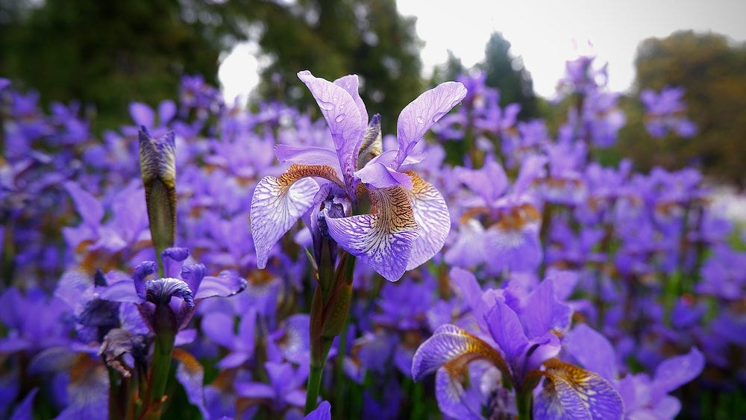

Portfolio Specification
Iris Flower Data Set

November 4 2o25

C00286249
Hafza Abdullahi

Table of Contents
Contents
Table of Contents 2
What is the Iris Flower classification 3
Dataset Structure 3
Statistical summary 4
Sepal Length Difference 5
Sepal Width Differences 6
Petal Length Differences 7
Petal width Differences 7
Summary of feature differences 8
Overview of the data using seaborn 9
Training the model 10
Preparing data for training using NumPy 11
Goal 12
Simple Classification rules using petal length 13
Modelling using logistic regression 15
Conclusion 17
References 17
Image References 18

What is the Iris Flower classification
The Iris flower data set or Fisher's Iris data set is a data set used and made famous by the British statistician and biologist Ronald Fisher in his 1936 paper.

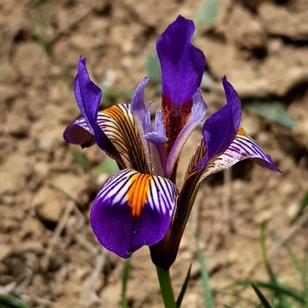
Figure 1: Iris flower

Dataset Structure
The dataset contains 3 species of Iris Flowers: setosa, versicolor, virginica. Each of these species has 50 samples which differ in these 4 categories
- Sepal length
- Sepal width
- Petal length
- petal length

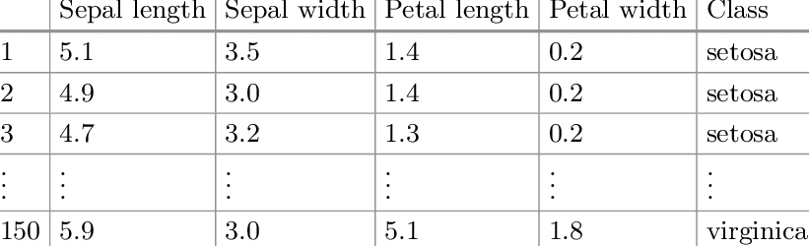
Figure 2: table containing the categories

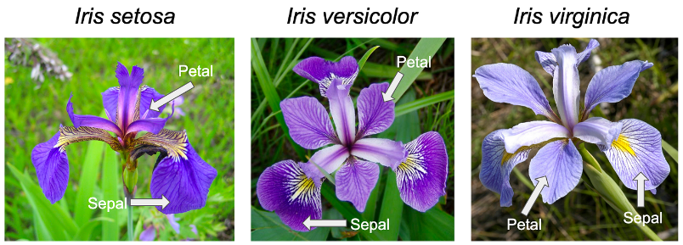
Figure 3: labelling of the flower parts

Statistical summary

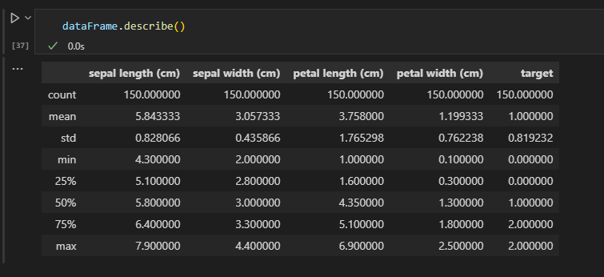
Figure 4: displays standard deviations of each measurement
source: my code

Somethings to note from this complete data
- 25% of all petals are shorter than 1.6 cm and smaller than 0.3 cm
- Smallest petal is 1.0 cm long × 0.1 cm wide
- Smallest sepal is 4.3 cm long × 2.0 cm wide
- Median Petal length (4.35 cm) is much higher than mean (3.76 cm)
- The Largest petal is 6.9 cm long × 2.5 cm wide
- The Largest sepal is 7.9 cm long × 4.4 cm wide
- Petal measurements show much wider ranges than sepal so they are going to be the most important
- Potential Clustering: The difference between the mean and median for petal length shows we might have unique groups

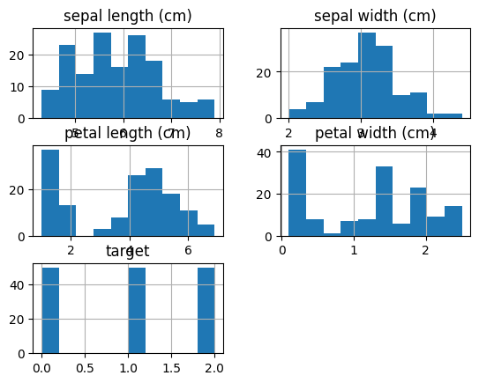
Figure 5: Histograms of features
source: my code
Task
Correctly identify an iris flower to the correct iris species using the sepal width and length and the petal length and width. This is a multiclass classification problem
How? Lets compare Features of the target to each category in the dataset using seaborn, a library built for better visualization of data. It has better plotting tools and hue changes compared to matplot library. It’s also cleaner and easier to use since it handles automatic styling and spacing.

Sepal Length Difference
The legend has the names of the species names instead of the numbers, but what does this graph mean? We can clearly see that setosa flowers have the shortest sepal length while versicolor has medium and virginica being the group with the largest. This is clear separation and difference we can use these to identify what species a flower belongs to.
Note: there is an overlap between versicolor and virginica so using sepal length alone to identify is not enough.

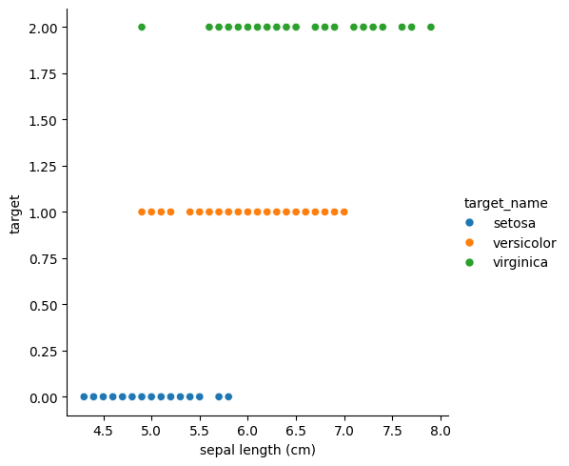
Figure 6: showing clear distinctions between the species when it comes to sepal length

Sepal Width Differences

A lot more overlapping can be seen with petal width so this is not a good unique identifier but still we can see versicolor has the smallest sepal width and setosa has the biggest
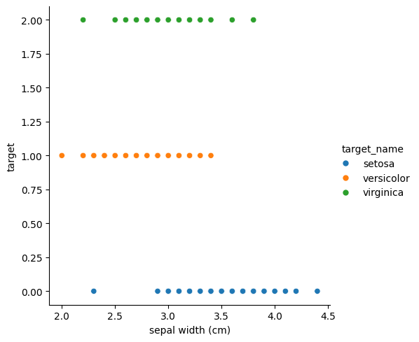
Figure 6: showing clear distinctions between the species when it comes to sepal width
source: my code

Petal Length Differences

This is a great unique identifier for setosa, since it doesn’t overlap at all with the two other species. This means we can tell setosa flowers just based off the petal length!

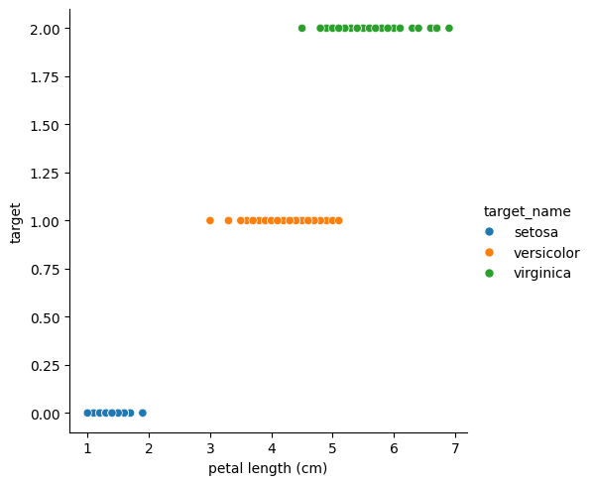
Figure 6: showing clear distinctions for setosa when it comes to petal length
Source: my code

Petal width Differences

Like petal length, petal width is also a unique identifier for setosa flowers
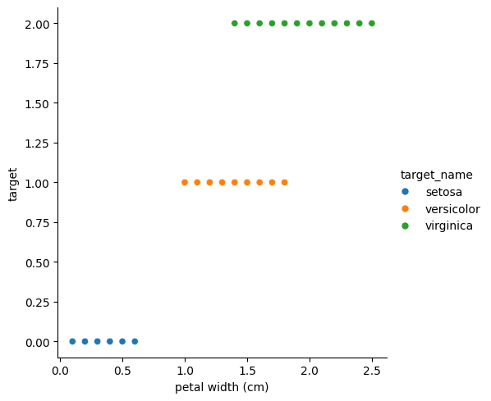
Figure 7: showing clear distinctions for setosa when it comes to petal width
Source: my code

Summary of feature differences

Unique Identifiers for Setosa:
- Petal length and petal width are the strongest unique identifiers for Setosa flowers
- Setosa has significantly smaller petals that don't overlap at all with the other two species
- This means we can instantly identify Setosa flowers just by looking at petal measurements alone, which is good! Easy identification

Challenges with Versicolor and Virginica:
- These two species overlap in all four features, making them harder to distinguish
- Sepal length shows some a little separation but still has noticeable overlap
- Sepal width has the most overlap and is the weakest identifier
- We cannot rely on any single feature to perfectly separate Versicolor from Virginica

Solution for Classification:
To identify all three species with accuracy, we need to use all four features together in a machine learning model. While Setosa can be easily spotted by its small petals, distinguishing between Versicolor and Virginica requires analysing the combination of sepal and petal measurements to find the subtle patterns that separate them.

Overview of the data using seaborn
code: seaborn.pairplot(dataFrame, hue="target_name")

In here we can see all the data features plotting against each other using seaborn pairplot, setosa flowers data can be seen In their own clusters when it comes to petal length and width, the rest of data shows their relationships.
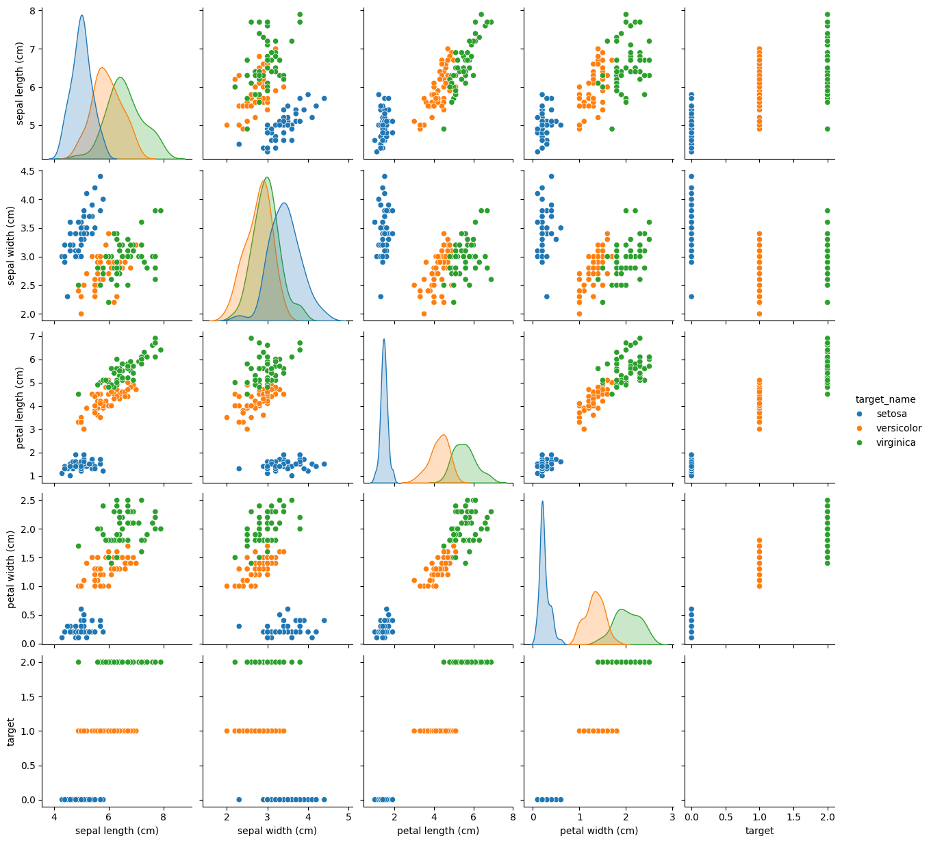
Figure 8: overview of the data plotted against each other
Source: my code

Training the model

Test data aka unseen data:
Before training, its important that we keep a portion of the data that the model hasn’t seen before called the test set to use for the final test of our model. This is to make sure we don’t do a final test with data the model has seen already and knows the answer to already. By doing this we get a true measure of how well the model performs and how well it correctly identifies a brand new iris flower.

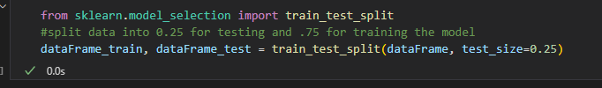
Figure 9: code splitting data into train and test data
Source: my code

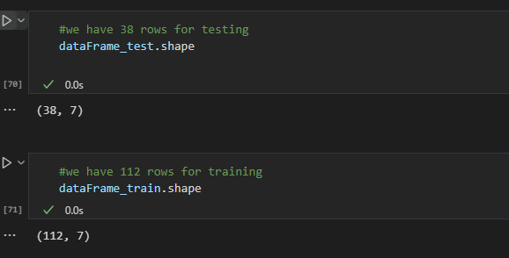
Figure 10: code showing data split into 38 test rows and 112 train rows
Source: my code

Preparing data for training using NumPy

To clean the data we need to remove the species and target name columns and just have a NumPy array of the numbers

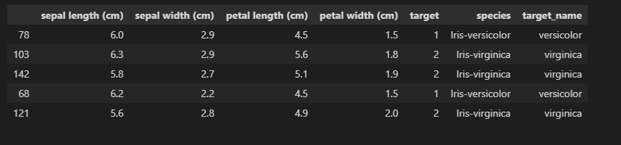
Figure 11: code showing before cleaning
Source: my code

Data after removing those columns

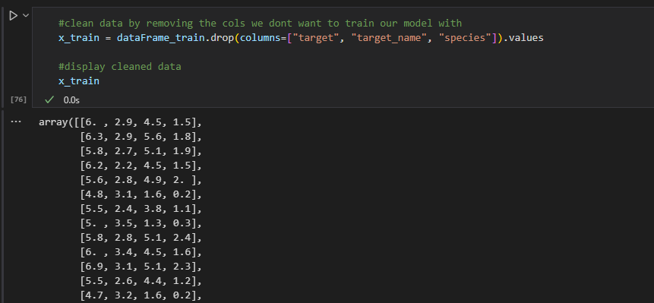
Figure 12: code data ready for training
Source: my code

Goal
If we had a wheel randomly spinning what a new flower might be without seeing it, what will we get? Mathematically speaking it should guess correctly 1/3 of the time, since there are 3 options and the classes are evenly balanced. So, our goal Is to create a model that guesses the answer correctly more than 1/3 of the time

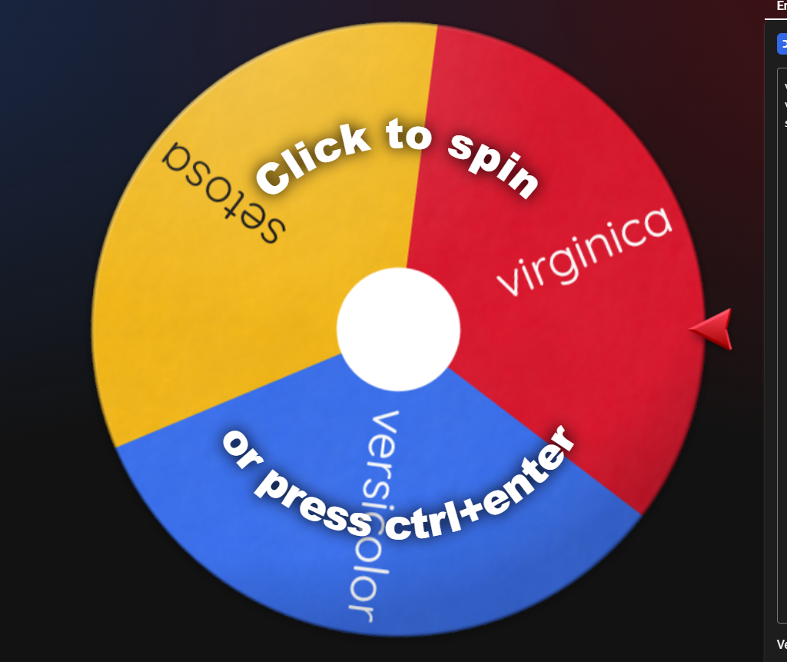
Figure 13: spinner wheel with 3 options

Simple Classification rules using petal length

Using this graph again

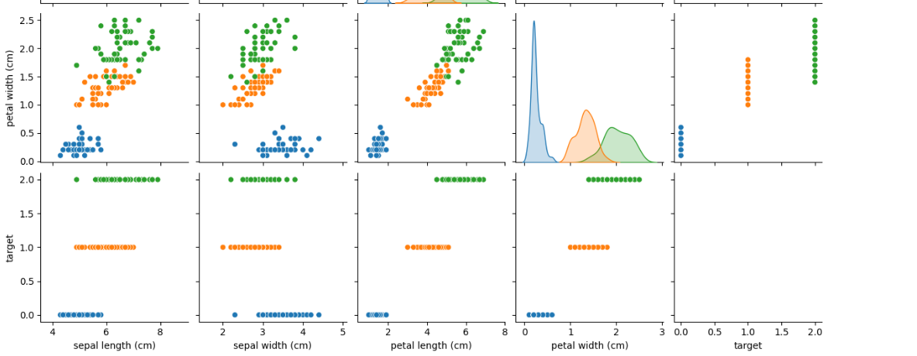
Figure 14: data features graphed against each other showing some classification
Source: my code

We can see that

- If the petal length is less than 2.5 it’s a setosa flower
- If the petal length is less than 4.8 but bigger than 2.5 it’s versicolor
- If both statements are false, then it’s a virginica

Sample input and output without machine learning
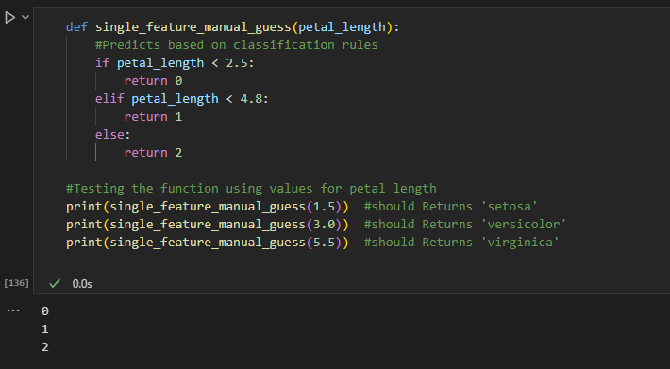
Figure 15: single feature guessing without any learning
Source: my code
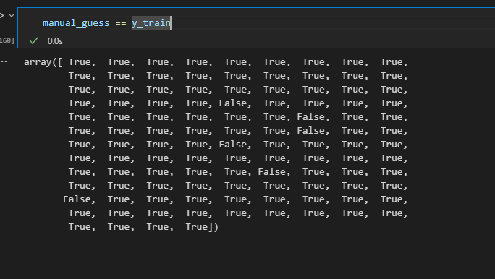
Figure 16: output of manual guessing with the training data
Source: my code

We can see that the manual guessing was pretty accurate

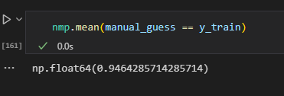
Figure 17: output of manual guessing mean
Source: my code

Modelling using logistic regression
Logistical regression is a classification algorithm that tries to find patterns in data and separate them by classes by drawing boundaries between them. This is perfect for our iris flower dataset which has 3 species
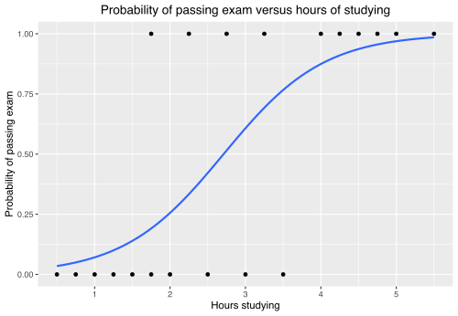
Figure 18: logistic regression

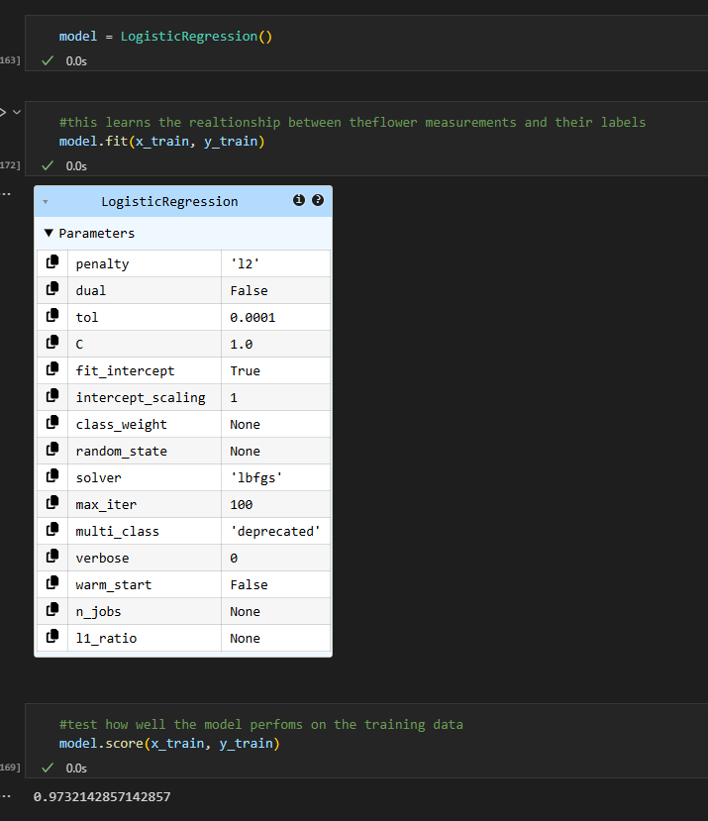
Figure 19: data training using logistic regression
Source: my code

Note:
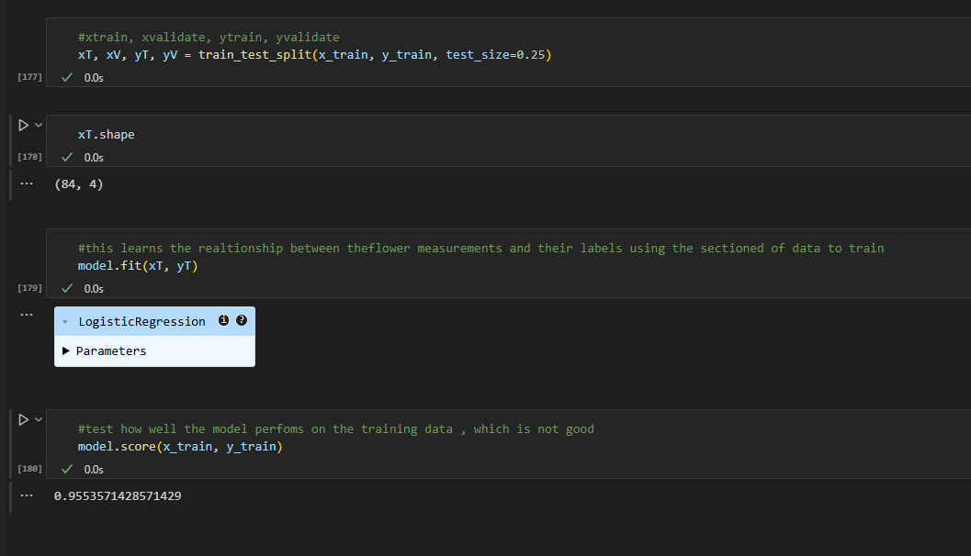
Figure 20: decrease in accuracy since we used less data
Source: my code

Lets go back to the goal
The manual testing accuracy
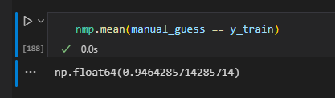

vs our model which performs better overall
note how the unseen data is less accurate
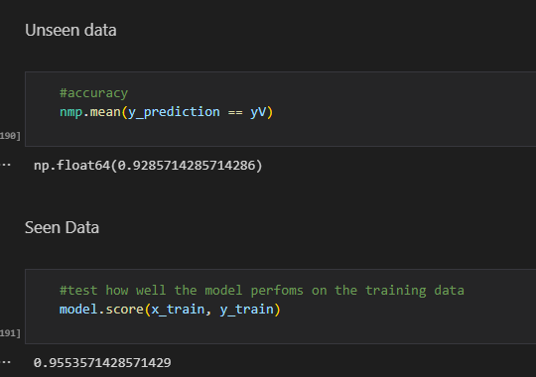

Conclusion
This Iris Flower Classification project demonstrated how data analysis and machine learning can be used to accurately identify flower species based on measurable traits like petal length, width etc. After looking at the data, it was clear that petal length was a good unique trait for identifying Setosa, which showed no overlap with the other two classes.

This result showed that while it performed worse than the manual guessing with the unseen data, with better training it could do better. The seen data set performed better overall

References
- https://en.wikipedia.org/wiki/Iris_flower_data_set
- https://archive.ics.uci.edu/dataset/53/iris
- https://scikit-learn.org/1.4/auto_examples/datasets/plot_ir

Image References
- [1] https://thursd.com/articles/iris-flower-meaning
- [13] https://wheelofnames.com/
- [18] https://en.wikipedia.org/wiki/Logistic_regression

